CSA 1568 Cloud Computing and Big Data Analytics for Data Streaming

EXPT 1

Create a simple cloud software application and provide it as a service using any Cloud Service Provider to demonstrate Software as a Service (SaaS).

OUTPUT:

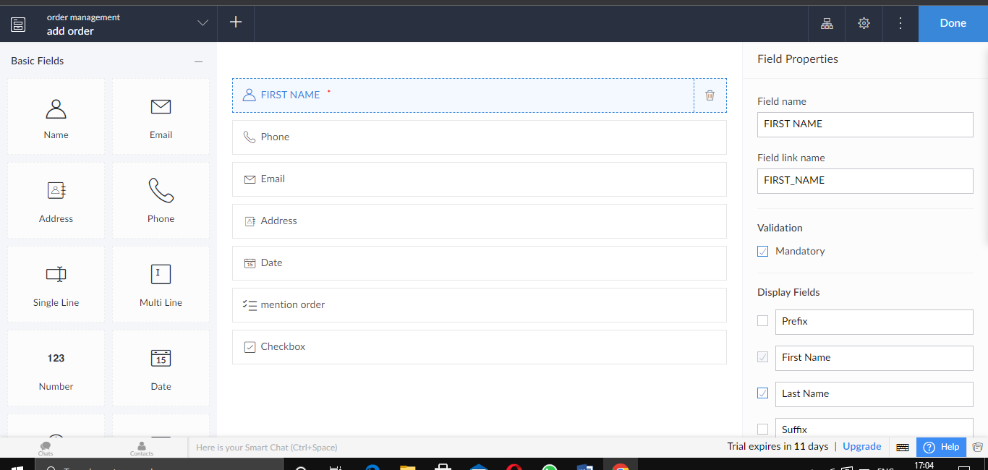

EXPT 2

Create a simple cloud software application for Flight Reservation System using any Cloud Service Provider to demonstrate SaaS.

OUTPUT

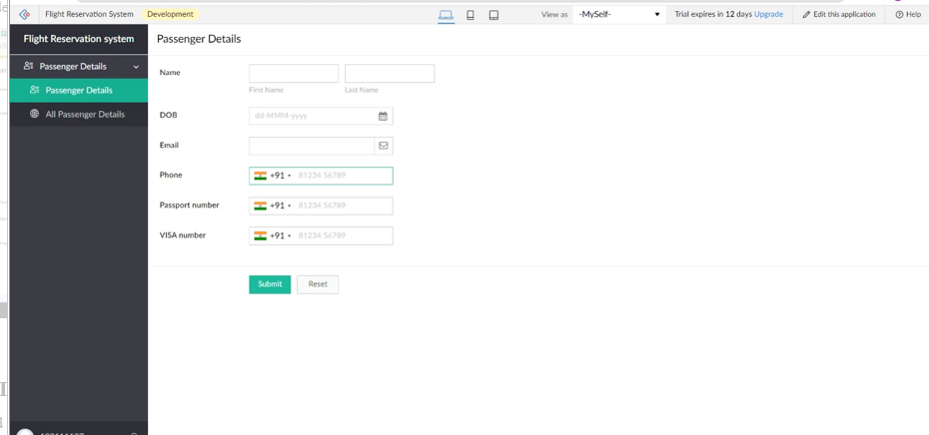

EXPT 3

Create a simple cloud software application for Property Buying & Rental process (In Chennai city) using any Cloud Service Provider to demonstrate SaaS.

OUTPUT:

